HECAT – Disruptive Technologies Supporting Labour Market Decision Making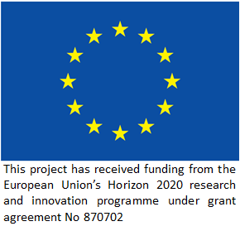
Our Methods
Our project brings a human-centred research approach to the study of algorithms and the PES’ which implement them.
This approach is guided by sociological, ethnographic, and anthropological research methods, which gather data via interviews, focus groups and participant observation.
We believe that if unemployment is to be truly understood, we must interview and speak with those who experience it directly, including unemployed individuals, policy makers and PES workers.
Project Background
The Global Financial Crisis (GFC) inflicted severe damage on the global economy, one of the most significant being an historic rise in long-term unemployment. In the aftermath of the GFC, with falling tax revenues and increasing spending, many governments implemented Active Labour Market Policies (ALMPs) to ‘activate’ seemingly ‘inactive’ unemployed people who were at risk of long-term unemployment. Rising budgetary pressures, combined with hiring freezes led to the development of algorithms which would profile the unemployed based on various characteristics (age, skills, qualifications etc.) and sort them into various categories (low / high risk) based on their expected likelihood of remaining unemployed. Those people who were classified as likely to become long-term unemployed (6+ months) received targeted interventions aimed at helping them find work – thereby avoiding the ‘scarring’ effect of long-term unemployment.
For a PES, modern analytic techniques such as algorithmic analysis are essential to ensure that the scarce resource of welfare is rationed fairly and sensibly, i.e. a person already likely to find work does not need much help, this would be a waste of resources. The problem is that most (if not all) of these algorithmic systems are flawed, with accuracy rates fluctuating between 45% - 80% and evincing ethical problems around fairness, justice, data protection, and consent.
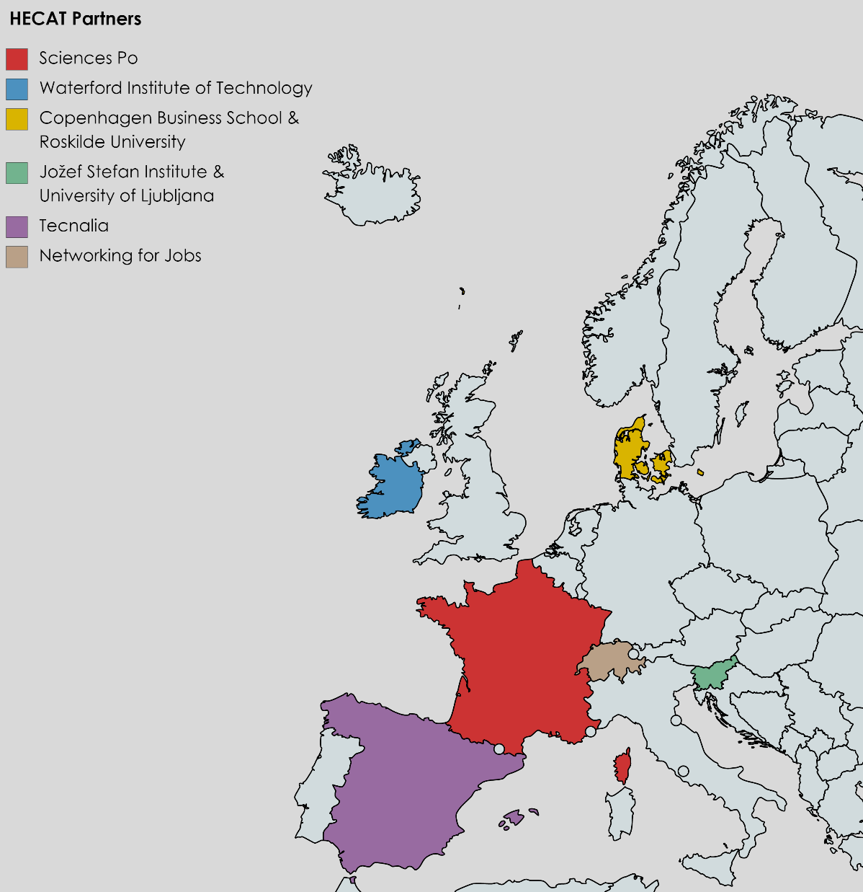
The HECAT project is proudly international and multidisciplinary, factors which we believe are essential to the success of our project. These include:
The Waterford Institute of Technology, which has been studying unemployment since 2012 through the WUERC project, and are leading the HECAT project.
Sciences Po, who bring their nuance and expertise on unemployment, both from a policy and person-centred stance.
The Copenhagen Business School, who contribute a rich and deep understanding of algorithmic profiling.
The Jožef Stefan Institute, University of Ljubljana and Tecnalia who imbue the project with their expertise on gamification, algorithms, statistical modelling and user interface building.

Our partners
The Team
This consortium brings together a community of scholars, public services, private services, citizens groups and practitioners that links:
- current PES administrative practitioners and private third sector organisations who understand service need and deployment constraints
- empirical researchers around the transformation of work in the 4th industrial revolution (such as flexibilisation, casualisation, risk-shifting self-employment)
- experts on the analytics, metricisation and statistics on the labour market
- theorists on the moral foundations of social welfare systems
- specialists with the technical and operational skills to deploy solutions in PES site

